LOCAL SERVICES FINDER
@CREATIVITY THINK (9483175986/7019689991)

ABSTRACT:
Local Services Finder is a web application that connects users with local service providers for home, office, and personal needs. Users can search, filter, and book services, while administrators manage providers, monitor bookings, and analyze platform activity. Built using Django, Django Rest Framework, React, Leaflet, and Axios, the platform ensures real-time service tracking, efficient provider management, and analytics-driven insights for administrators..

INTRODUCTION OF THE PROJECT:
Finding reliable local services can be time-consuming and inefficient. The Local Services Finder simplifies this process by providing a centralized web platform where users can discover, book, and track service providers. Administrators can manage providers, monitor service delivery, and analyze engagement data through dashboards. The application integrates backend reliability with a responsive frontend and real-time geolocation services for accurate service discovery..

PROJECT OBJECTIVES:

• Enable users to discover local services quickly
• Provide seamless booking and service tracking
• Facilitate provider management and analytics for admins
• Centralize listings with search and filter capabilities
• Provide dashboards for users and admins
• Ensure real-time updates on service status
• Improve service reliability and transparency
• Enhance efficiency in local service discovery

PROBLEM OF THE STATEMENT:
Locating and booking reliable local services is often inconvenient, relying on word-of-mouth or multiple platforms. This leads to inefficiencies, delays, and lack of accountability. The Local Services Finder solves these problems by centralizing provider listings, enabling booking, tracking service progress, and providing analytics for administrators to monitor and optimize service delivery..

MOTIVATION OF THE PROJECT:
• Improve access to local services for users
• Provide real-time service tracking and booking
• Simplify management of service providers
• Increase reliability and accountability in service delivery
• Use dashboards to monitor and analyze platform performance

BLOCK DAIGRAM OF PROJECT:

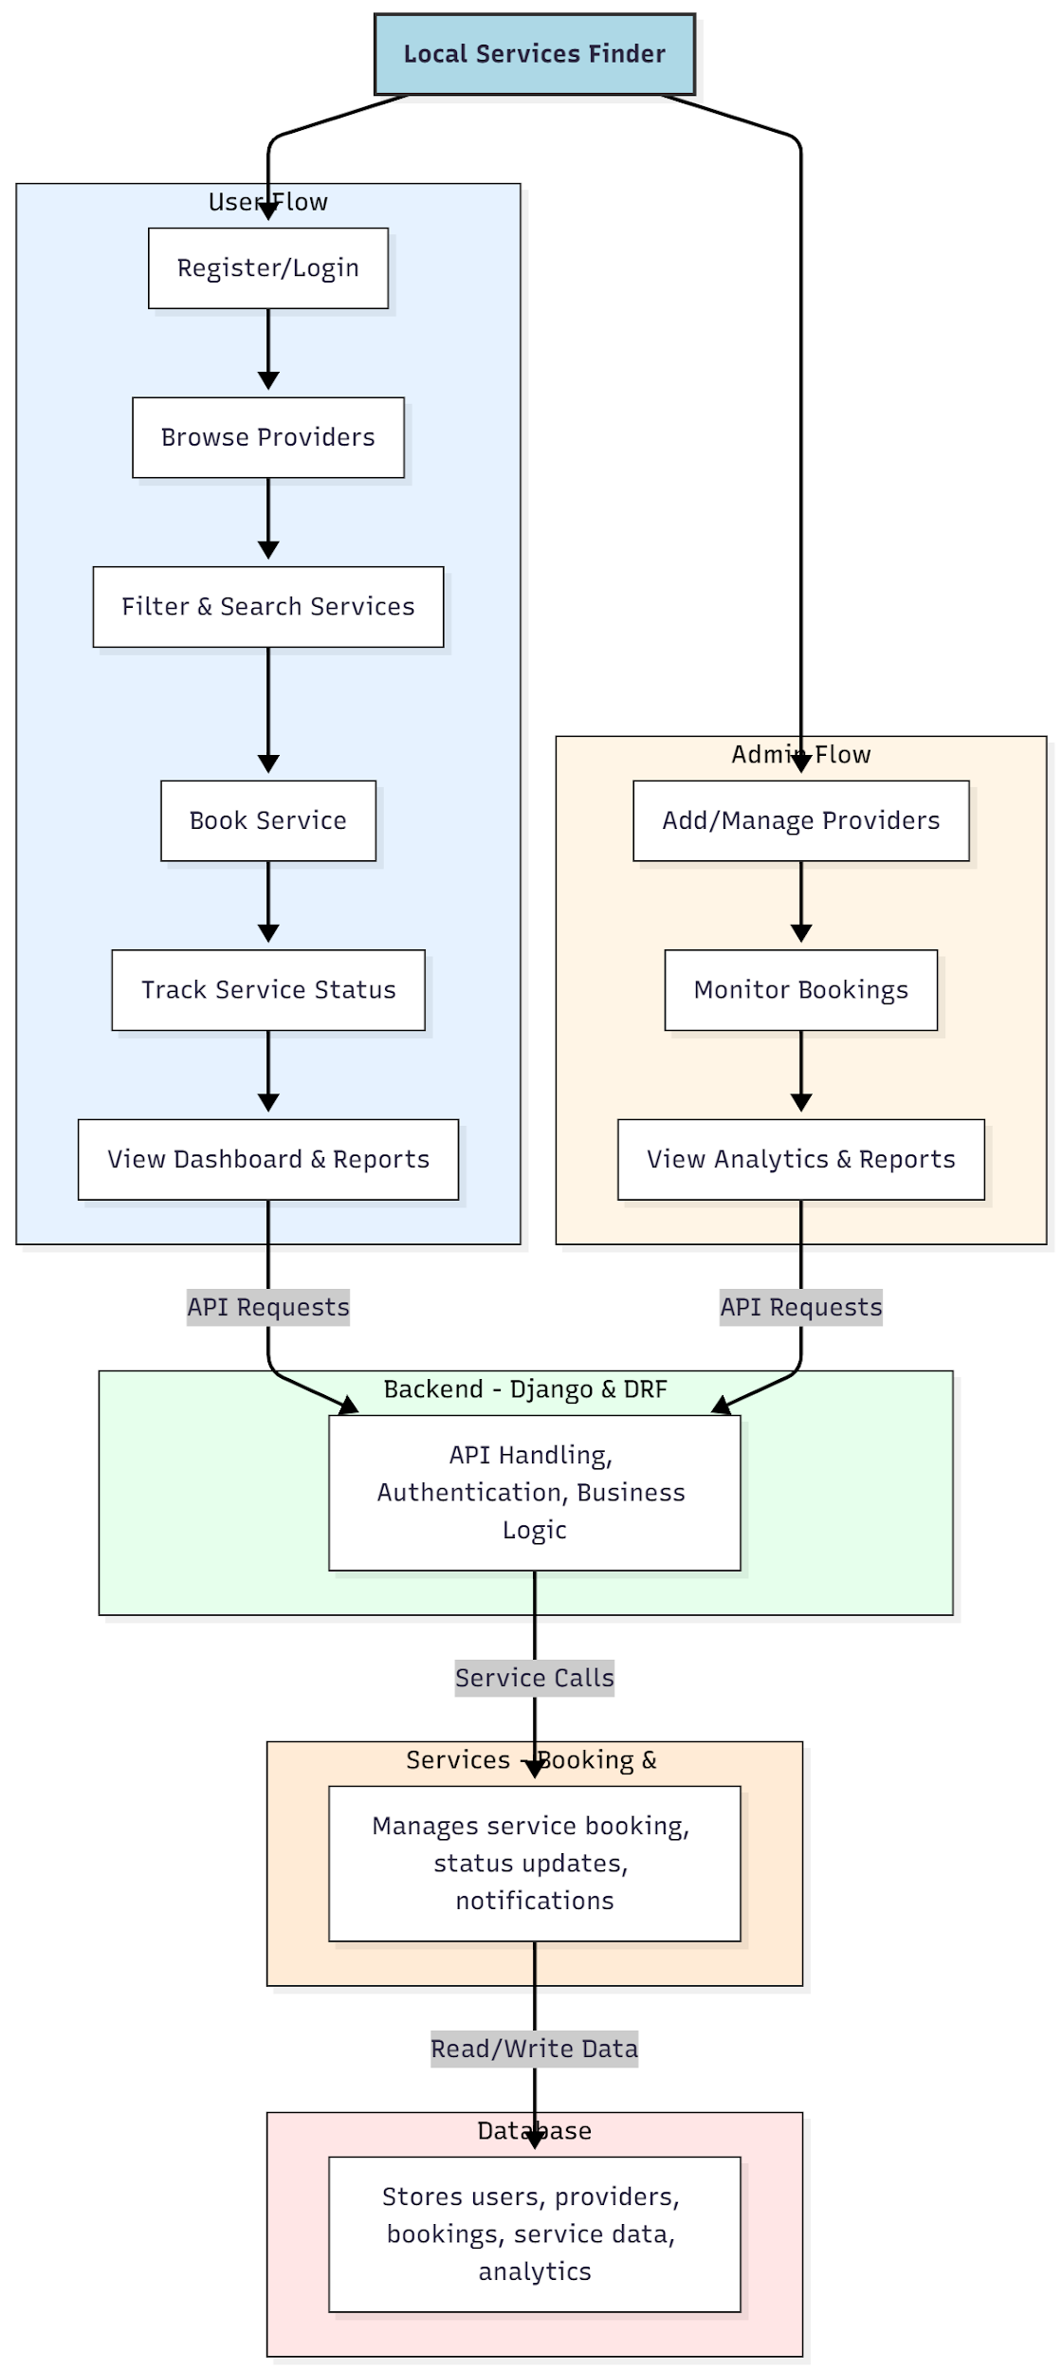

WORKING OF THE PROJECT:
Users register and log in to browse available service providers. They can search and filter services based on location or type, book the desired service, and track its status in real-time. Administrators add and manage providers, monitor bookings, and view detailed analytics through dashboards. The backend handles authentication, API requests, and business logic, while services manage notifications and booking processes. All data including users, providers, bookings, and analytics are stored in a central database for efficient management and reporting..

SOFTWARE REQUIREMENT:
- Backend:
  - Python 3.x
  - Django
  - Django REST Framework
  - SQLite/PostgreSQL
- Frontend:
  - Node.js and npm
  - React.js
  - Axios
- Development Tools:
  - Visual Studio Code
  - Postman (for testing APIs)
  - Git/GitHub (for version control)
- Server/Deployment (Optional):
  - Gunicorn, Nginx, or Heroku/AWS for hosting

ADVANTAGES OF THE PROJECT:

• Centralized platform for local service discovery
• Real-time booking and status tracking
• Simplifies provider management for admins
• Dashboard analytics for decision-making
• User-friendly interface for booking and tracking
• Reduces delays and improves service reliability
• Notifications for users and admins
• Supports data-driven platform improvements

APPLICATIONS OF THE PROJECT:
• Local home and office service discovery
• Booking platforms for cleaning, plumbing, repair, or tutoring
• On-demand service marketplaces
• Administrative dashboards for service providers
• Analytics-driven business insights
• Event or service coordination platforms
• Neighborhood and community service networks
• Mobile or web applications for instant service access

REFERENCES:

- Django REST Framework Documentation — Django Software Foundation. Django Documentation. Available: https://docs.djangoproject.com/
- Django REST Framework. DRF Documentation. Available: https://www.django-rest-framework.org/
- React. React Official Documentation. Available: https://reactjs.org/docs/getting-started.html
- Redux. Redux Documentation. Available: https://redux.js.org/introduction/getting-started
- PostgreSQL Global Development Group. PostgreSQL Documentation. Available: https://www.postgresql.org/docs/
- MySQL. MySQL Reference Manual. Available: https://dev.mysql.com/doc/
- Git. Git Documentation. Available: https://git-scm.com/doc
- Node.js. Node.js Documentation. Available: https://nodejs.org/en/docs/
- Axios. Axios Documentation. Available: https://axios-http.com/docs/intro
- Socket.io Documentation – https://socket.io/docs/

